1. Install PostgreSQL for Windows
   1. <http://www.postgresqltutorial.com/install-postgresql/>
   2. <https://www.guru99.com/download-install-postgresql.html>
2. Install Anaconda that comes with Python 3.7
   1. <https://www.datacamp.com/community/tutorials/installing-anaconda-windows>
   2. Comes with Python, Pip
3. Install OpenSSL
   1. <https://stackoverflow.com/questions/41328451/ssl-module-in-python-is-not-available-when-installing-package-with-pip3/44758621>
   2. <https://slproweb.com/products/Win32OpenSSL.html>
   3. Install all 32 and 64 bit SSL

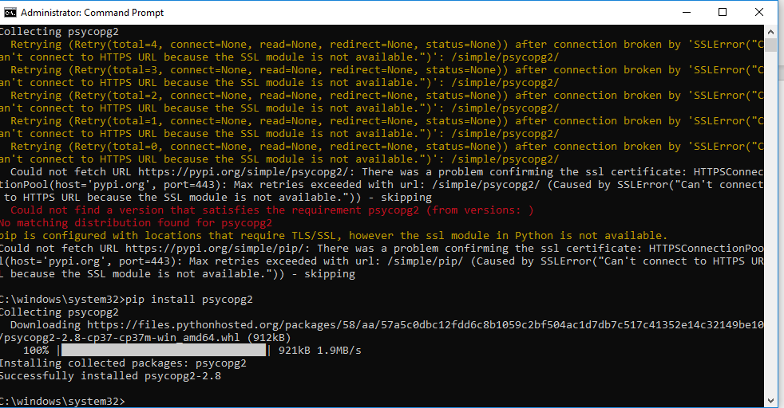

1. Open Juypter and do as below

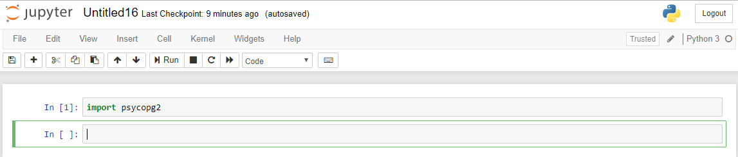

1. Open CMD > run as administrator > Type pip install Cassandra-driver. This will import all the necessary drivers required for jyupter to work
2. Open Juypeter and type Import Cassandra